**What’s my function?**

**Instructions.**

This is a guessing game. You are playing against the other team. They are trying to guess the following function:

Add some additional info to this function, e.g., turning pts

y=0.5(x-2)(x+3)(x+1)

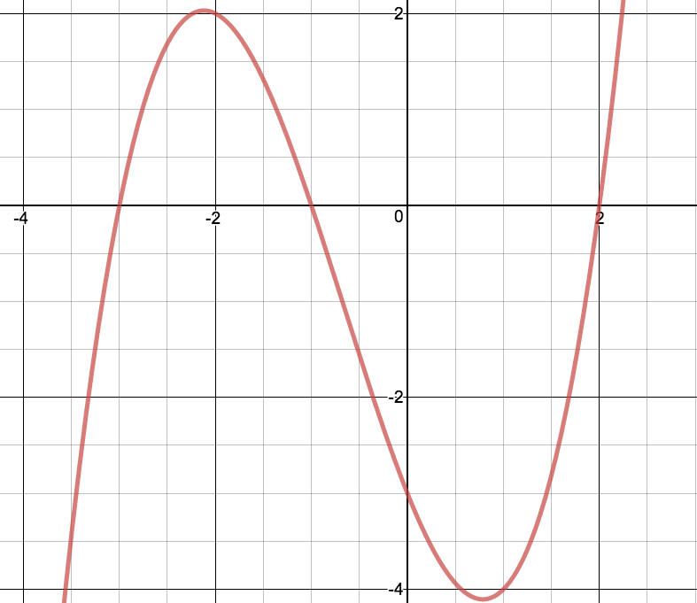

They are allowed to ask you a total of 8 questions, BUT, they are only allowed to ask you 4 questions about this function. The other four questions they are allowed to ask must be about the derivative function!

The two teams will take turns in asking your questions. They must be yes-no answer questions. You have 3 minutes to plan which questions you might like to ask, then the game will begin. You must draw your final function in the space provided below. You may use technology to aid you in your working.

**What’s my function?**

**Instructions.**

This is a guessing game. You are playing against the other team. They are trying to guess the following function:

Add some additional info to this function, e.g., turning pts

y=(x+1)(x-1)(x+2)(x-2)

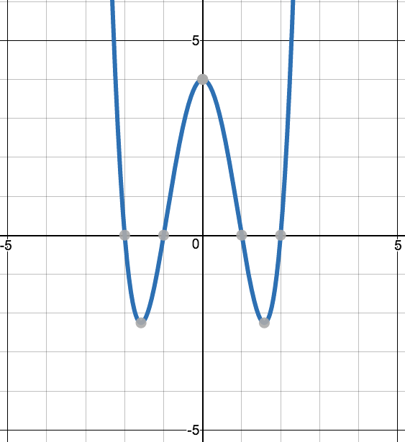

They are allowed to ask you a total of 8 questions, BUT, they are only allowed to ask you 4 questions about this function. The other four questions they are allowed to ask must be about the derivative function!

The two teams will take turns in asking your questions. They must be yes-no answer questions. You have 3 minutes to plan which questions you might like to ask, then the game will begin. You must draw your final function in the space provided below. You may use technology to aid you in your working.